**10th Annual Pharmacy Home Project Meeting**

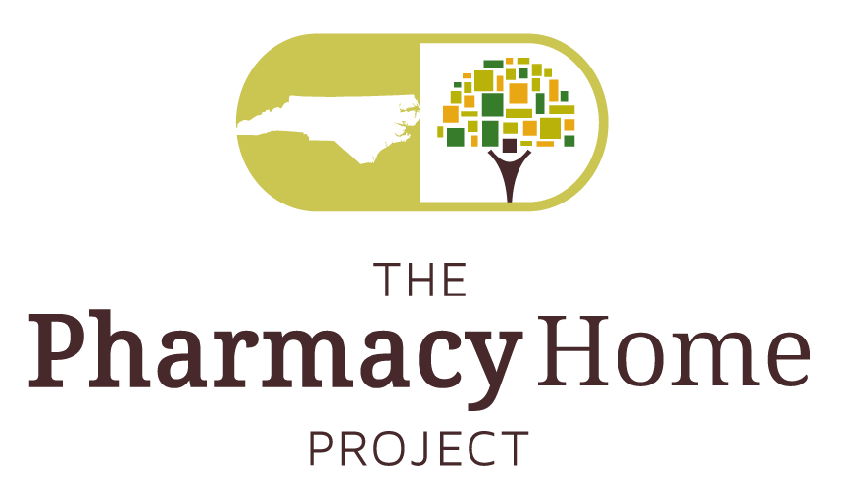

**”Value Based Payment Models-The Way Forward for Pharmacy”**

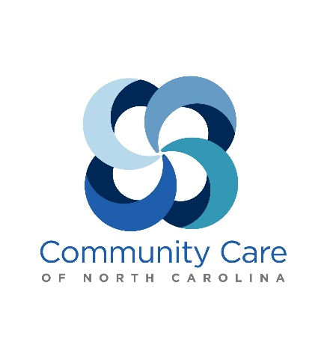

[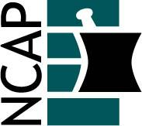](http://www.ncpharmacists.org/)[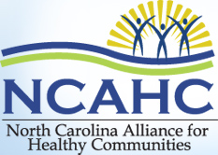](http://www.ncahc.org/index.html)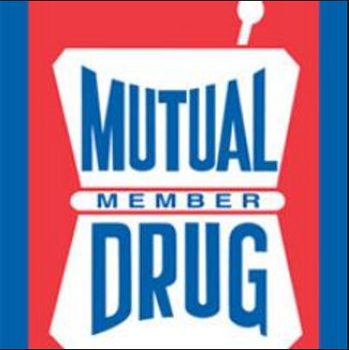



**Wednesday, February 8, 2017; 7:30 AM - 5:30 PM**

**Durham Convention Center**

The 10th Annual Pharmacy Home Project meeting builds on the history of nine years of Community Care of North Carolina (CCNC) pharmacy program meetings but is bolstered by new partnerships with the North Carolina Alliance for Healthy Communities (NCAHC), the North Carolina Association of Pharmacists (NCAP), Mutual Drug, and the UNC Eshelman School of Pharmacy.  This conference started with nine individuals in 2007 at the inception of the CCNC Pharmacy Home Project. The theme for this year’s event is “Value Based Payment Models-The Way Forward for Pharmacy”. This year, a total of 6.75 hours of ACPE continuing education credit is available for pharmacists. For those pharmacists who wish to apply for CE credits, please click here <https://pharmacy-ncu.learningexpressce.com/index.cfm?fa=view&eventID=7421> for registration and payment.

**ACPE Number 0046-9999-17-016-L04-P**

**8:30-9:30a.m.- MACRA & MIPS Overview for the Health Care Team**

- Why should we care?

- What does CMM have to do with it?

Medicare Access and CHIP Reauthorization Act (MACRA) and Merit-based Incentive Payment System (MIPS) are mechanisms utilized by CMS to restructure how healthcare providers are reimbursed, moving into the domain of value based payments. This session is intended to inform participants regarding the potential impact of this change, how to thrive in this new environment, and how these changes are important to pharmacists, provision of CMM, and the value of pharmacists to the patient care team.

Objectives: Upon completion of this knowledge based session, participants will be able to:

1. Describe how value based payments will impact their practice and healthcare at large
2. Discuss strategies to position practices for success in the era of value based payments
3. Develop a sustainable mechanism for providing CMM to targeted patients

**9:30-10:30a.m. -“Getting the Medications Right”: The Importance of CMM in Value-Based Payment Models**

- Pharmacy perspective

- Payer perspective (to include HIE and data exchange perspective)

- Physician perspective (to include MACRA/MIPS implications)

- (optional) Policy perspective

Over the last two decades, comprehensive medication management has emerged as a practice to improve outcomes, control costs and enhance the satisfaction of clinicians and patients alike. This new report examines comprehensive medication management and the role of the pharmacist in patient care. This report offers insights into CMM services identifying factors contributing to--and inhibiting – practice success. This session will look at the findings from this report from the perspective of stakeholders, including pharmacists, payers, physicians, and patients in terms of how to push forward the recommendations to the benefit of all stakeholders.

Objectives: Upon completion of this knowledge based session, participants will be able to:

1. Discuss key concepts from the report
2. Identify barriers to implementing CMM and potential solutions
3. Develop strategies to collaborate with stakeholders to optimize patient care via CMM implementation

**10:45-11:45 a.m.-“Getting the Medications Right”: The Importance of CMM in Value-Based Payment Models-**

**Panel Discussion**

This session is an extension of the above introductory module and will allow the representative stakeholders to discuss their own experiences (successes/failures/lessons learned) in this arena.

Objectives: Upon participation in this knowledge based panel discussion, attendees will be able to:

1. Identify mechanisms to overcome barriers to CMM implementation
2. Describe best practices with CMM that are translatable to their practice.

**2017 Annual Pharmacy Home Conference Breakout Sessions**

**ACPE Number 0046-9999-17-017-L04-P**

**Afternoon Breakout Sessions (12:30-2:20 p.m.)**: The session will offer eight topics, with a repeat offering in the second hour.

**Breakout Session 1- Workflow Integration into Community Pharmacy**

Description: To successfully implement medication management services in the community pharmacy setting, workflow integration must be considered. During this breakout session, attendees will discuss strategies to incorporate med management services into community pharmacy workflows to increase efficiency and productivity.

Learning Objectives for this knowledge based breakout session:

1. Discuss the benefits of developing workflows for community pharmacy med management services
2. Evaluate examples of med management workflows as related to your community pharmacy practice
3. Apply lessons learned to develop workflows in your practice site

**Breakout Session 2- Measuring Your Efforts**

Description: Measurement of med management services has potential internal and external benefits for pharmacists providing med management services. During this breakout session, attendees will discuss strategies to measure med management efforts, and consider potential benefits.

Learning Objectives for this knowledge based breakout session:

1. List key data elements and resources available for performance measurement activities
2. Discuss strategies for incorporating performance measurement activities into workflows
3. List potential internal and external benefits for performance measurement
4. Apply lessons learned to develop performance measurement activities in your practice site

**Breakout Session 3- Community Pharmacist Services for Opioid Safety**

The Centers for Disease Control has noted the national problem with opioid misuse and abuse which has led to increased morbidity and mortality, and issued comprehensive guidelines in March 2016 to assist providers in navigating the use of opioids for chronic pain. Pharmacists have a significant role to play in the safe and effective use of opioids for chronic pain. During this breakout session, participants will discuss services to support providers and patients in this regard, barriers to successful implementation, and strategies to overcome these barriers.

Learning Objectives for this knowledge based breakout session:

1. List four key services that community pharmacists can provide to promote opioid safety
2. Identify two barriers to successful implementation of these services
3. Apply strategies to overcome barriers to successful opioid safety service implementation

**Breakout Session 4- Use of screening/assessments for patient/provider engagement**

Screening for detection and subsequent referral for treatment has been a mainstay of many pharmacy practices for many years (blood pressure, point of care labs, pregnancy testing), however some pharmacies are moving into other non-traditional areas such as alcohol use disorder and depression screening and referral.

Learning Objectives for this knowledge based breakout session:

1. List three key services that community pharmacists can provide in collaboration with primary care medical home practices in the area of alcohol use disorder and depression screening.
2. Identify two barriers to successful implementation of these services
3. Apply strategies to overcome barriers to successful service implementation

**Breakout Session 5- Health Information Technology**

Description: Health information technology is a core component to connecting care team members in the strive for value-based care. Participants will review and discuss recent progress with HIT that has potential to influence the effectiveness or delivery of CMM.

Learning Objectives for this knowledge based breakout session:

1. Review the Pharmacy eCare Plan standard
2. Discuss why the eCare Plan can be considered is a game changer for CMM delivered outside of ambulatory care medical practices
3. Establish methods to prepare the pharmacy community for participation in integrated care planning

**Breakout Session 6- Interdisciplinary Team Communication**

Description: Many different members of the health care team with different scopes of practice interact with patients about their medications. The ideal scenario is to use an integrated care plan that is continually improved using CMM but also allows each team member to contribute in a “top of license” fashion.

Learning Objectives for this knowledge based breakout session:

1. Identify how each of the following disciplines can effectively contribute to the delivery of CMM: pharmacy technicians, social workers, nurses, pharmacists, and prescribers.
2. Describe existing communication channels that exist between these disciplines and determine if they are rich enough to support team-based CMM.
3. Determine what types of communication channels would be needed between disciplines to support team-based CMM and evaluate the importance of technology.

**Breakout Session 7- Resourcing CMM Effectively & Efficiently**

Description: While pharmacists and prescribers have the broadest scope of practice as it relates to the core activities of CMM, they are also somewhat scarce and costly resources. Other members of the health care team, including pharmacy technicians, social workers, and nurses can be utilized to help make CMM more effective and more efficient.

Learning Objectives for this knowledge based breakout session:

1. Describe how each of the following disciplines can effectively contribute to the delivery of CMM: pharmacy technicians, social workers, nurses, pharmacists, and prescribers.
2. Identify which components of CMM would be most cost-effectively handled by a pharmacy technician, social worker, or nurse.
3. Design an example system of care that would effectively integrate these resources into CMM.
4. Describe how the role of these health care team members in CMM could vary across care settings.

**Breakout Session 8- Workflow Integration in an Ambulatory Care Clinic**

Description: CMM requires the opportunity to have an in depth initial assessment with the patient followed by regular opportunities for follow up. These activities have unique workflows in different settings of care.

Learning Objectives for this knowledge based breakout session:

1. Review the type and duration of patient visits (in person, telephonic) that are necessary to conduct CMM in an ambulatory care clinic.
2. Identify which health care team members are commonly involved in ambulatory care CMM visits and whether there is opportunity to increase the interdisciplinary involvement.
3. Discuss success strategies and lessons learned across participants regarding CMM workflow in an ambulatory care clinic environment.

**2017 Annual Pharmacy Home Conference -Pearls Sessions**

**ACPE Number 0046-9999-17-018-L04-P**

**2:45 PM – 4:15 PM Pearls Session**

Session description: This “boots on the ground” discussion focuses on methods for developing and measuring the effect of CMM models in real world practice environments, as well as methods for financial and functional sustainability. There are six topics (10-12 min each) with interactive audience questions/answers at the session closing.

Learning Objectives:

1. How to determine which practices/providers to partner/collaborate with and developing trust
2. CMM as a practice standard- initial lessons learned
3. Growing the CMM practice- reimbursement/payment strategies for sustainability
4. Mature CMM -collaborative practice agreements and other successful methods
5. Building for the future- teaching CMM to students
6. Engaging patients in CMM

Learning Objectives for this knowledge based pearls session:

1. Identify methods to select engage practices which predict for a successful collaborative relationship.
2. Discuss barriers to implementation and maintenance of the CMM practice model and strategies to overcome these obstacles to success.
3. Identify strategies and methods to maximize successful claims submission to move towards a financially sustainable practice model.

**4:15 PM – 5:05 PM Final Breakout Session**

Small group discussion(s) on each of the above pearls topics (facilitated by the presenter of each pearl presentation)

1. How to determine which practices/providers to partner/collaborate with and developing trust

Objective: Participants will discuss methods to identify elements of practices which predict for a successful collaborative relationship.

1. CMM as a practice standard- initial lessons learned

Objective: Identify and discuss key successes and methods to position pharmacists for success in establishing a practice based on CMM.

1. Growing the CMM practice- reimbursement/payment strategies for sustainability

Objective: Identify strategies and methods to maximize successful claims submission to move towards a financially sustainable practice model.

1. Mature CMM -collaborative practice agreements and other successful methods

Objective: Discuss barriers to implementation and maintenance of this practice model and strategies to overcome these obstacles to success.

1. Building for the future- teaching CMM to students

Objective: Discuss key areas of focus in engaging students in use of CMM as a foundation of practice.

1. Engaging patients in CMM

Objective: Discuss practical strategies to engage patients in CMM such as motivation interviewing and others.

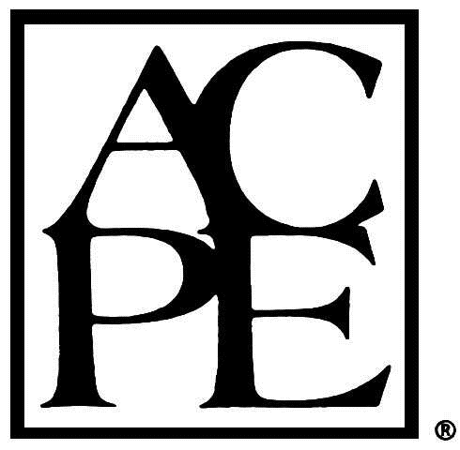

The University Of North Carolina Eshelman School Of Pharmacy is accredited by the Accreditation Council for Pharmacy Education as a provider of continuing pharmacy education. The program ACPE# 0046-9999-17-016-L04-P, 0046-9999-17-017-L04-P, and 0046-9999-17-018-L04-P provides 6.75 contact hours of continuing pharmacy education credit. To receive CE credit, you must complete the CE attendance form and the online evaluation of the program. Statements of credit can be viewed and printed in CPE Monitor in approximately 2 to 3 weeks.

**Registration for the Conference:**

**Registration for the conference is free, however pre-registration is required for meeting planning purposes, by clicking here. By registering for and attending the conference, you will be provided access to all meeting materials, snacks, and meals. If you wish to secure pharmacy CE for this event, please use the link above to register and pay.**

**Questions?**

**For additional questions regarding the conference or logistics around the conference, please contact:**

Trish Fitzpatrick

Administrative/Logistics Coordinator

Community Care of North Carolina

2300 Rexwoods Drive, Suite 380

Raleigh, NC 27607

919-745-2432  **|** 919-745-2352  **|\*** [tfitzpatrick@n3cn.org](mailto:tfitzpatrick@n3cn.org)